Chip back potential is the level which bulk silicon is maintained by on-chip connection, or it is the level to which the chip back must be connected when specifically stated below. If no potential is given the chip back should be isolated.

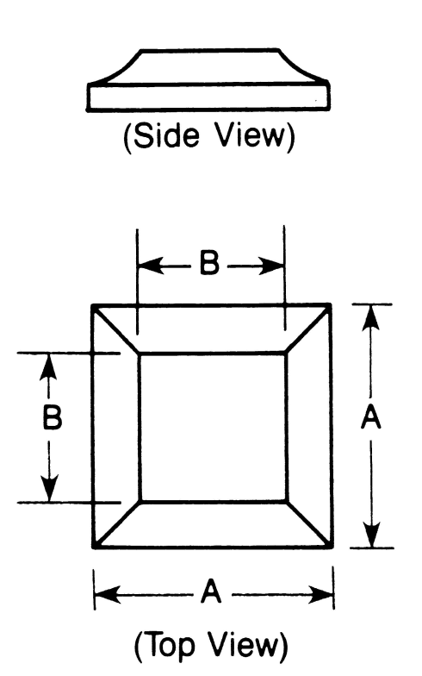
.019”
.033”
.019”
CATHODE

.033”

Top Material: Au
Backside Material: Au
Bond Pad Size: .019 X .019”
Backside Potential: ANODE
Mask Ref:

APPROVED BY: DK DIE SIZE .033” X .033” DATE: 11/3/21
MFG: MICROSEMI THICKNESS .007” P/N: 1N4477
DG 10.1.2

Rev B, 7/1

